Name: _______________________________________

APUSH Period 1 Review
1491-1607

- Early Native Americans arrive on North American continent conflicting research
  - Low sea levels exposed a land bridge connecting Eurasia with North America where the Bering Sea now lies between Siberia and Alaska.
    - It is believed that most Native Americans crossed this land bridge.
    - Some evidence claims that small groups may have reached North America with crude boats.

- They evolved into hundreds of tribes, spoke different languages, and practiced different cultures.

- Estimates of the native population in the Americas in the 1490’s vary from 50 million to 100 million people.

Mayans – in Central America | Incas – in Peru | Aztecs – in Mexico
- Yucatan Peninsula  - staple crop = corn | - staple crop = potatoes | - capital city = Tenochtitlán.  - Population of Tenochtitlán = 200,000 people (equal to size of largest cities in Europe)  - staple crop = corn
- highly organized societies, carried on extensive trade, created calendars based on accurate scientific observation
- Built elaborate cities and carried on far-flung commerce
- They were talented mathematicians.
- They offered human sacrifices to their gods.
- cultivated crops that provided a stable food supply, particularly corn
- created large irrigation systems

Cultivation of Corn spread across the Americas from the Mexican heartland. Everywhere it was planted, corn began to transform nomadic hunting bands into settled agricultural villagers This was a slow process.
- At the time of European arrival: Only nation-state that existed in North America was the Aztecs.

Native Americans by Region

Atlantic Seaboard | Northwest | Southwest
- built timber and bark lodgings along rivers  - Rivers & Atlantic Ocean provided rich food source | - Along Pacific Coast from Alaska to California  - Rich diet based on hunting, fishing, & gathering  - carved large totem poles | - modern New Mexico & Arizona  - Anasazis, Hokokam, Pueblos  - farmed -> used irrigation  - lived in caves, under cliffs, & multistoried buildings

Northeast | Great Plains | Midwest Settlements
- Iroquois Confederation – a political union of 5 tribes  - Seneca  - Cayuga  - Onodaga  - Oneida  - Mohawk  - matrilineal  - lived in longhouses | - nomadic tribes hunted buffalo  - lived in tepees covered in animal skins  OR  - sedentary people farmed & traded  - lived permanently in earthen lodges along rivers  - raised corn, beans, & squash  HORSES (from Europeans) caused tribes like the Lakota Sioux to move from farming to hunting. | Ohio River Valley  - Mound builders  - Adena-Hopewell Culture  Mississippian Settlements  - Cahokia – near present day East St. Louis was largest Midwest settlement at 30,000 inhabitants

Three-Sister Farming
- Three Sisters = corn, beans, & squash
- allowed for higher populations to settle down
- However, by the time of Columbus’ arrival, most people in the Americans lived in semi permanent settlements in groups seldom exceeding 300 people.
  - men were hunters
  - women gathered plants & nuts or grew crops such as corn, beans, and tobacco.

European Exploration:
- Norse seafarers from Scandinavia came to the northeastern shore of North America, near present-day Newfoundland, to a spot they called Vinland.
- Europeans were looking for new trade routes to India.

- Christopher Columbus
  - sailed for Spain
  - October 12, 1492, he and his crew landed on an island in the Bahamas.
  - Columbus called the natives “Indians” since he thought he was in India.

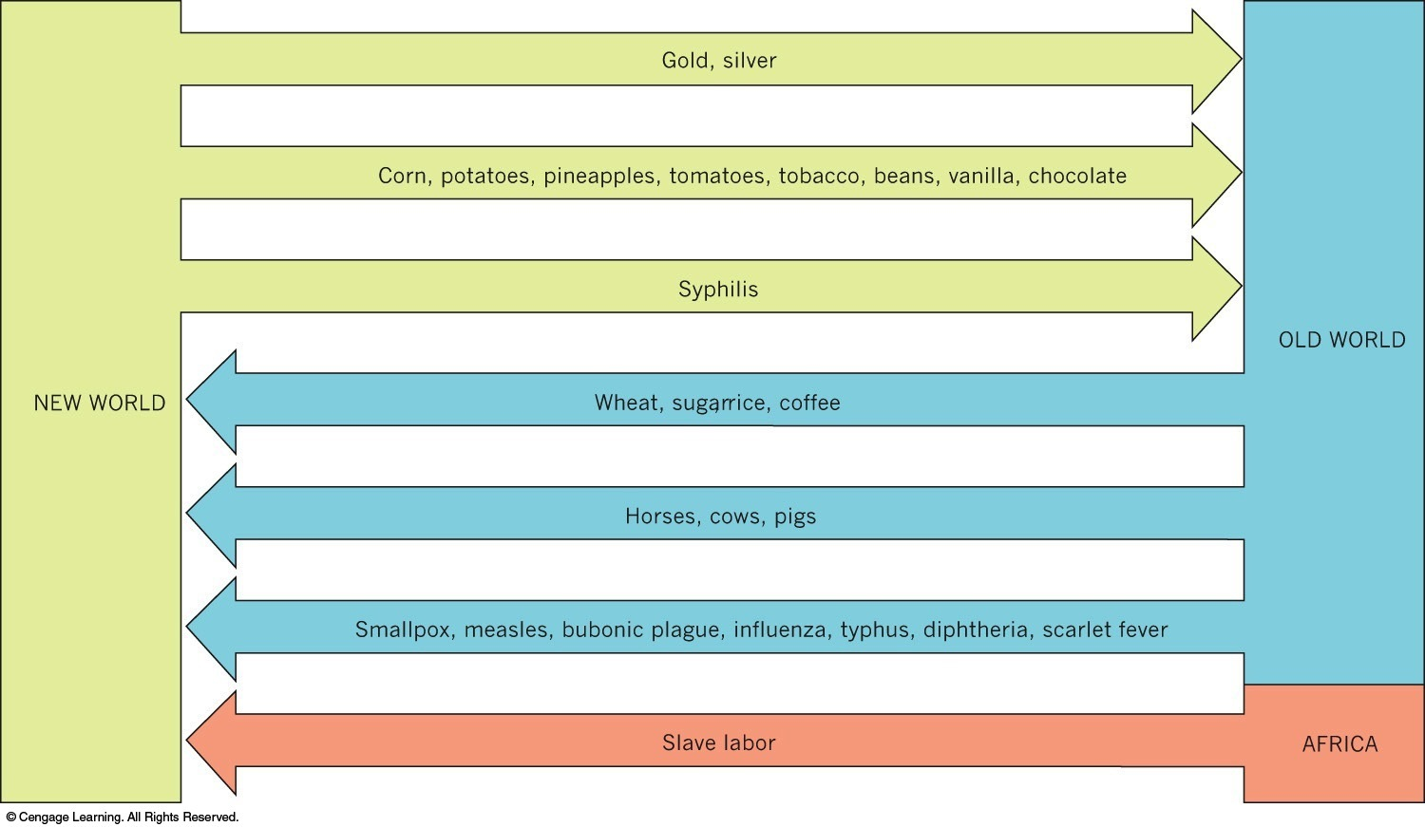
Columbian exchange
- Europeans brought “Old World” crops and Animals
  - Introduction of horses changed many Native American societies.
- A “sugar revolution” took place in the European diet, fueled by the forced migration of millions of Africans to work the canefields and sugar mills of the New World.
- An exchange of diseases between the explorers and the natives took place.
  - Approximately 90% of Native Americans died from European diseases, especially smallpox

Treaty of Tordesillas
- Spain & Portugal both claimed overlapping territory in “New World.”
- Spain secured its claim to Columbus’s discovery in the Treaty of Tordesillas (1494)
  - line passed through modern day Brazil. (This explains why they speak Portuguese in Brazil)
  - Portugal got Brazil, Spain claimed rest of the Americas

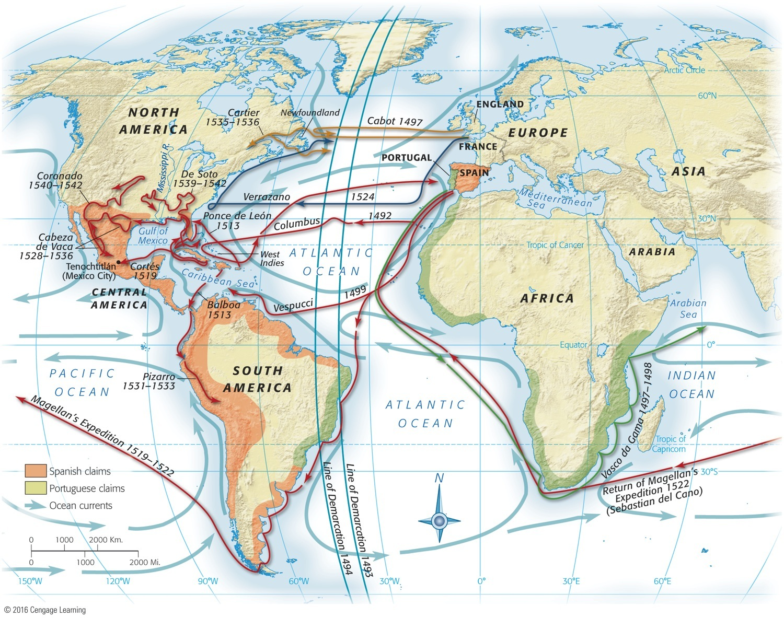

encomienda system
- The Spanish encomienda system allowed the government to “commend” Indians to certain colonists in return for promise to try to Christianize them.
- Indians had to farm or work in mines.
- Spanish missionary Bartolomé de Las Casas called it “a moral pestilence invented by Satan.”

asiento system
- As European diseases reduced native populations, Spanish brought enslaved people from West Africa.

Reasons for Spanish Exploration:
- In service of God, in search of gold and glory, Spanish conquistadores (conquerors) came to the New World.
Fall of Aztecs
- 1519 Cortez tries to capture the Aztec capital at Tenochtitlán.
- Aztec chieftain Moctezuma sent ambassadors to greet Cortés and invite Cortés and his men to the capital city.
- On June 30, 1520, noche triste (sad night), the Aztecs attacked Cortés.
- On August 13, 1521, Cortés laid siege to the city and the Aztecs capitulated. The combination of conquest and disease took its toll.

Fall of Incas
- 1532: Francisco Pizarro crushed Incas (Peru).

English Claims
- Sir Walter Raleigh attempted a settlement at Roanoke Island off the coast of North Carolina in 1587.
  - Roanoke’s settlers disappeared

French Claims
- Giovanni de Verrazano explored the northeast coast, including NY
- Quebec is 1st permanent French settlement in America
- eventually will explore Mississippi River & establish Louisiana

Dutch Claims
- explored the Hudson River Valley
- claimed New Amsterdam (later to be called New York)
- granted a private company, the Dutch West India Company control of the region for economic gain.

Spanish Claims
- Florida
  - St. Augustine – permanent colony in 1565
    - Oldest city in North America established by Europeans
- New Mexico
  - Santa Fe was established as the capital of New Mexico in 1610
  - Pope’s Rebellion in 1680 over harsh efforts to Christianize the American Indians drove the Spanish out until 1692.
- Texas
- California
  - established permanent settlements in San Diego (1769) and San Francisco (1776)
  - established missions along the California coast by members of the Franciscan order
    - Father Junipero Serra founded nine missions.

Relationships between Europeans & Native Americas
- Spanish
  - Used the Native Americans as labor
- French
  - viewed Native Americans as potential economic and military allies
  - maintained good relations with the Native Americans
  - due to fewer colonies, farms, and towns, the French posed a lesser threat to the N.A.’s
- English
  - Early on (in Massachusetts) they coexisted peacefully
  - relations eventually gave way to conflict and open warfare

